https://world-nuclear-news.org/articles/regulator-oks-hermes-2-construction-permit
21.11.2024

Hermes 2 construction permits approved by US Nuclear Regulatory Commission
The US Nuclear Regulatory Commission has voted to issue construction permits to Kairos Power for the Hermes 2 Demonstration Plant.
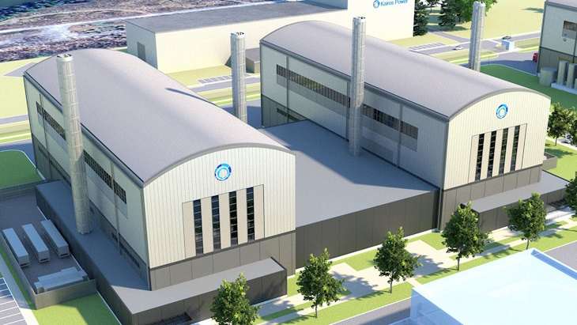A rendering of the Hermes 2 plant (Image: Kairos)
The permits will authorise Kairos to build a facility with two 35 MWt molten salt-cooled reactors that would also include a shared power generation system.
Kairos' Hermes Low-Power Demonstration Reactor became the first US Gen IV reactor to receive a Nuclear Regulatory Commission (NRC) construction permit in December 2023, and now Hermes 2 becomes the first electricity-producing Gen IV plant to be approved for construction in the USA, Kairos said.
Hermes 2 is intended to provide operational data to support the development of a larger version for commercial electricity production. Kairos submitted its application to build Hermes 2 in July 2023, and the NRC issued its final safety evaluation for the permits in July this year, and the final environmental assessment for site in August.
"While keeping safety at the forefront, the permitting process was quite efficient, and we issued these permits in less than 18 months," said NRC Chair Christopher Hanson "This shows we can rapidly apply relevant conclusions from earlier reviews to promptly reach decisions on new reactors."
Following a new, streamlined mandatory hearing process conducted via written documents, the NRC said it has authorised the Office of Nuclear Reactor Regulation to issue the permits, having found the review by NRC staff of the Hermes 2 application "adequate to make the necessary regulatory safety and environmental findings". The permits are expected to be issued in the near future.
"The Commission's approval of the Hermes 2 construction permits marks an important step toward delivering clean electricity from advanced reactors to support decarbonisation," Kairos CEO and co-founder Mike Laufer said. "We are proud to lead the industry in advanced reactor licensing and look forward to continued collaboration with the NRC as we chart a path forward with future applications."
Hermes 2 plant will be built on land adjacent to the Hermes reactor, which is currently under construction. Kairos Power must apply for and obtain an operating licence from the NRC before the plant can start up.

